Diabetes

**PIP Quarter:**  Feb-Apr  May-Jul  Aug-Oct  Nov-Jan

1. **PDSA Example**

A sample activity using the PDSA Template to illustrate how to structure your quality improvement activity.

1. **PDSA Template**

The template to complete and store (for audit purposes) as part of your activity, guiding you through each stage of the PDSA cycle.

1. **CAT Recipe**

A step-by-step guide for filtering your patient cohort and running activity reports in CAT4 to support your activity.

1. **PHN Exchange**

A complementary data reporting tool that enhances your activity by providing valuable insights and benchmarking.





**Diabetes: A Chronic Condition with Growing Impact**

This month is an opportunity to raise awareness of diabetes, promote early detection, and support best-practice care for those living with the condition. At Diabetes Australia, the goal is clear: *a future where diabetes can do no harm*. Health professionals play a vital role in reducing the burden of diabetes through proactive screening, patient education, and evidence-based management.

Diabetes continues to be one of the most prevalent and costly chronic diseases in Australia.  
Regular monitoring through HbA1c testing is essential for assessing glycaemic control and reducing the risk of long-term complications in patients with Type 1, Type 2, or undefined diabetes.

* **1.3 million Australians are living with diagnosed diabetes** — with many more undiagnosed.
* **Diabetes is the leading cause of preventable blindness in adults.**
* **It significantly increases the risk of heart disease, kidney failure, and lower limb amputations.**
* **Up to 58% of Type 2 diabetes cases can be prevented with early intervention and lifestyle changes.**

Despite clear clinical guidelines, many patients with diabetes do not have an HbA1c result recorded annually — missing a key opportunity for timely intervention.

**Data from our PHN Dashboard**

* Out of the total patients 524173, there are 41133 patients diagnosed with diabetes in our region.
* Contributing factors – 37.44 obesity our PHN, QLD is 32.70 per 100
* Insufficient physical activity - 72.80 our PHN, QLD 67.88 per 100.

**Relevant PIP QI Measures**

* QIM1 -Proportion of patients with diabetes with a current HbA1c result
* QIM5 - Proportion of patients with diabetes who were immunised against influenza
* QIM10 - Proportion of patients with diabetes with a blood pressure result.

**PDSA: July 2025 – Diabetes Management: HbA1c Monitoring**

This month’s focus is on increasing the proportion of active eligible patients with Type 1, Type 2, or undefined diabetes who have had an HbA1c result recorded in the last 12 months.

Regular HbA1c testing enables appropriate clinical decision-making and supports patients in maintaining optimal glycaemic control.

Use this activity to identify gaps in monitoring, ensure accurate coding, and prioritise follow-up and recalls where needed.

**Resources**

* [National Diabetes Week (13–19 July)](https://www.diabetesaustralia.com.au/national-diabetes-week/)
* [Diabetes Risk Calculator](https://www.diabetesaustralia.com.au/risk-calculator/)
* [Health Professional Resources – Diabetes Australia](https://www.diabetesaustralia.com.au/health-professional-resources/)
* [NDSS Workplace Posters & Clinical Tools](https://www.ndss.com.au/health-professionals/workplace-posters/)

A PDSA cycle is a structured, step-by-step method that helps teams actively work through an improvement activity while also recording the process and outcomes for reflection and learning.

|  |  |
| --- | --- |
| **Practice name:** Example Practice | **Date:** 01/07/2025 |
| **Team member:** P. Manager | |

|  |  |
| --- | --- |
| PLAN | Describe the brainstorm idea you are planning to work on. (Idea) |
| Decide what you want to improve, what changes you'll try, and how you'll measure success. | |
| What do you want to achieve?  Increase the proportion of active eligible patients with Type 1, Type 2, or undefined diabetes who have had an HbA1c measurement recorded in the last 12 months, by the end of the PIP quarter.  What will you change?  Use PenCS CAT4 to identify eligible patients and recall them for HbA1c tests using HotDoc and opportunistic reminders at consultations.  Who will help?  QI Team, GP practice staff (reception, nurses, GPs), potentially support from PenCS CAT4 and HotDoc.  What do you need?   * PenCS CAT4 software to run reports on eligible diabetes patients who have not had their HbA1c recorded in the last 12 months. * HotDoc to send recall reminders to patients. * GP and nurse time to flag and discuss HbA1c testing during consultations. * Baseline data collected at the start of the PIP quarter.   How will you measure success?   * Track the proportion of eligible patients who have NOT had their HbA1c recorded in the last 12 months by comparing the baseline data in August 2025 to the result data collected in October 2025. * Use PenCS CAT4 and the QI Team to run reports and track the improvement. | |
| DO | **Who is going to do what? (Action)** |
| Put your plan into action and collect data. | |
| Actions at the beginning of the PIP quarter:   * Hold a team meeting to ensure all practice staff are aware of the QI activity and goals. * Gather feedback from the team to refine and improve the plan. * Discuss roles and responsibilities for report generation, patient recalls, and follow-up tasks.   During implementation:   * PenCS CAT4 was used to identify eligible diabetes patients who had not had their HbA1c recorded in the last 12 months. * HotDoc was used to send recall reminders to those patients for HbA1c testing. * Opportunistic reminders were provided to patients attending appointments. * Reports were run to establish baseline data for comparison. * Monitor progress regularly to ensure the plan is being followed and identify any issues early on.   At the end of the PIP quarter:   * Hold a follow-up team meeting to review results and discuss challenges. * Gather feedback to refine the process. | |
| STUDY | **Does the data show a change? (Reflection)** |
| Look at the results. Did the change work as expected? What did you learn? | |
| What data did you collect?   * Baseline: X eligible patients with no recorded HbA1c in past 12 months * Result: Y eligible patients still without HbA1c result * Improvement: Z fewer patients without a result — a Z% improvement   What did you learn?   * The recall system worked well and resulted in a measurable increase in recorded HbA1c tests. * Opportunistic reminders during appointments were effective in capturing additional patients. * Some patients required multiple reminders before booking their test. | |
| ACT | **Do you need to adjust the plan, or did everything go as expected? (What Next?)** |
| Decide what to do next—keep the change, adjust it, or try something different. | |
| What will you do next?   * Adopt: Continue using PenCS CAT4 and HotDoc for patient recalls, maintaining the increase in HbA1c testing. * Adapt: Explore ways to further personalise recall reminders or improve opportunistic reminders at appointments. * Abandon: If repeated reminders are ineffective or cause patient frustration, trial a one-time recall strategy.   Next Steps:   * Consider integrating SMS or phone call reminders for patients who do not respond to HotDoc. * Encourage GPs and nurses to set reminders within the patient record for future follow-ups. | |

**Please attach your data reports/results to this PDSA.**

|  |
| --- |
| Should your practice be audited, having these documents on hand will serve as evidence of the changes made, the data collected, and the outcomes achieved during the PDSA cycle. Ensure that the baseline data and result data are included, along with any relevant reports from PenCS CAT4 and HotDoc that were used to track the improvement. |

A PDSA cycle is a structured, step-by-step method that helps teams actively work through an improvement activity while also recording the process and outcomes for reflection and learning.

|  |  |
| --- | --- |
| **Practice name:** | **Date:** |
| **Team member:** | |

|  |  |
| --- | --- |
| PLAN | Describe the brainstorm idea you are planning to work on. (Idea) |
| Decide what you want to improve, what changes you'll try, and how you'll measure success. | |
| What do you want to achieve?  What will you change?  Who will help?    What do you need?   * … * … * … * …   How will you measure success?   * … * … | |
| DO | **Who is going to do what? (Action)** |
| Put your plan into action and collect data. | |
| Actions at the beginning of the PIP quarter:   * … * … * …   During implementation:   * … * … * … * …   At the end of the PIP quarter:   * … * … | |
| STUDY | **Does the data show a change? (Reflection)** |
| Look at the results. Did the change work as expected? What did you learn? | |
| What data did you collect?   * Baseline: * Result: * Improvement:   What did you learn?   * … * … | |
| ACT | **Do you need to adjust the plan, or did everything go as expected? (What Next?)** |
| Decide what to do next—keep the change, adjust it, or try something different. | |
| What will you do next?   * Adopt: * Adapt: * Abandon:   Next Steps:   * … | |

**Please attach your data reports/results to this PDSA.**

|  |
| --- |
| Should your practice be audited, having these documents on hand will serve as evidence of the changes made, the data collected, and the outcomes achieved during the PDSA cycle. Ensure that the baseline data and result data are included, along with any relevant reports from PenCS CAT4 and HotDoc that were used to track the improvement. |

**Identify active diabetes patients with no HbA1c recorded in the last 12 months**

**FILTER STEPS**

Navigate to **‘General’** tab and select Activity **‘Active (3x in 2 yrs)’**.

Navigate to **‘Conditions’** tab, under the **‘Chronic’** subtab, and select the **‘Diabetes-Yes’** checkbox.

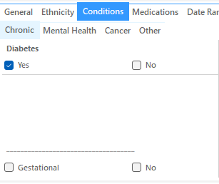

Navigate to **‘Date Range (Results)’** tab and select the **‘≤ 12 mths’** option.

Now all filter criteria have been set, please click on **'Recalculate'** to apply the filter:



To see the full report, first minimise the filter panel by clicking on the     in the top left corner.

**REPORT STEPS**

Select the **‘Pathology’** tab and the **‘HbA1c’** subtab.

Select the **‘No HbA1c Recorded’** section of the graph.

"CAT4 only tracks MBS items billed at your practice. Some patients may have claims elsewhere, but as we've filtered for active regular patients, these assessments should ideally be done in your clinic."

**NOTE:** Keep ‘Patient Count’ manageable based on staff capacity. A targeted approach ensures completion without disrupting business as usual. Need help refining numbers? Contact your PHN Primary Care Liaison Officer or email[practicesupport@ddwmphn.com.au](mailto:practicesupport@ddwmphn.com.au)

On the right-hand side of the Reports pane, you will see **‘Export’** and **‘Print’** icons.

You can save a soft-copy by selecting **‘Export’** or a hard-copy by selecting **‘Print’**.

If you chose to export a soft copy of your report, click on the drop-down arrow next to the Floppy Disc **‘Save’** Icon. This is where you will select how you would like to save the file.

**PDF:** Fixed Layout Document

**DOCX:** Word Document

**XLSX:** Excel Spreadsheet

**CSV:** Excel Data Table - great for bulk recall-reminders using HotDoc etc.

Please ensure that you attach your data reports to your PDSAs at the beginning and end of each quarter.

Be sure to attach your data reports to your PDSAs at the beginning and end of each quarter. If it’s not recorded, it didn’t happen! Should the Department come searching, you **MUST** have a record of your QI activities and the treasure trove of data to prove it. **X marks the spot—bury it somewhere you'll always find it!**

**Unlock powerful data insights at the click of a button with PHN Exchange**

You may find the **PHN Exchange GP Hub Data Reports** useful as a complementary reporting resource. The PHN Exchange is an innovative, web-based quality improvement tool that allows your practice to benchmark its data against the PHN catchment average. This provides valuable insights to identify areas for improvement.

Practices that share data with us can access PHN Exchange through the PHN Exchange Portal. Benchmarking reports can help track progress, align with PIP QI activities, and support strategic planning for proactive practice management.

To access the PHN Exchange please visit [DDWM PHN Exchange Portal](https://phnexchange.com.au/home.html?phn=304)

Your practice can monitor trends over a **12-month period** through the **GP Hub**.

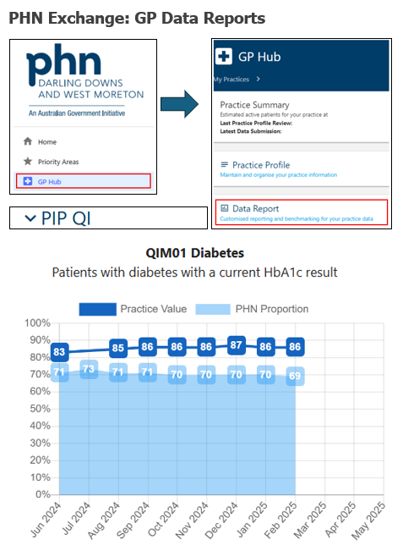

If you require assistance accessing or navigating your PHN Exchange data reports, please contact your PHNs Primary Care Liaison Officer or email [practicesupport@ddwmphn.com.au](mailto:practicesupport@ddwmphn.com.au)





You've conquered this QI Quest and **LEVELLED UP** your practice— but the journey doesn’t end here. A new challenge awaits in the next quarter... **Are you ready to embark on your next QI adventure?"**