Men’s Health

**PIP Quarter:**  Feb-Apr  May-Jul  Aug-Oct  Nov-Jan

1. **PDSA Example**

A sample activity using the PDSA Template to illustrate how to structure your quality improvement activity.

1. **PDSA Template**

The template to complete and store (for audit purposes) as part of your activity, guiding you through each stage of the PDSA cycle.

1. **CAT Recipe**

A step-by-step guide for filtering your patient cohort and running activity reports in CAT4 to support your activity.

1. **PHN Exchange**

A complementary data reporting tool that enhances your activity by providing valuable insights and benchmarking.





**Men’s Health: Addressing the Health Gap**



**June marks Men’s Health Month** — an important opportunity to focus on the health and wellbeing of men and boys in our communities. Men are at greater risk of dying prematurely from preventable causes, yet health check uptake among men remains low.

* **50 men die every day in Australia from preventable causes.**
* **Australian men die, on average, 5.4 years younger than women.**
* **Timely health checks can significantly reduce the risk of early death.**

**Relevant PIP QI Measures**

* **QIM3** – Proportion of patients with a weight classification
* **QIM7** – Proportion of patients with an alcohol consumption status
* **QIM10** – Proportion of patients with diabetes with a blood pressure result

**PDSA: June 2025 – 45–49 Health Assessments**

Increase the proportion of active eligible male patients aged 45–49 who have completed a 45–49 Health Assessment by the end of the PIP quarter. This is a targeted preventive health initiative that aligns with PIP QI and MBS priorities and supports improved outcomes in a high-risk population.

**Resources**

* [Australian Men’s Health Forum](https://www.amhf.org.au/)
* [About Men’s Health](https://www.amhf.org.au/about)
* [My Health for Life Program](https://www.myhealthforlife.com.au/)



A PDSA cycle is a structured, step-by-step method that helps teams actively work through an improvement activity while also recording the process and outcomes for reflection and learning.

|  |  |
| --- | --- |
| **Practice name:** Example Practice | **Date:** 01/05/2025 |
| **Team member:** P. Manager | |

|  |  |
| --- | --- |
| PLAN | Describe the brainstorm idea you are planning to work on. (Idea) |
| Decide what you want to improve, what changes you'll try, and how you'll measure success. | |
| What do you want to achieve?  Increase the proportion of active eligible male patients aged 45–49 who have completed a 45–49 Health Assessment, by the end of the PIP quarter.  What will you change?  Use PenCS CAT4 to identify eligible male patients aged 45–49 without a recorded Health Assessment. Implement recalls and offer opportunistic assessments during appointments.  Who will help?  GPs, practice nurses, reception staff, and the QI team. Support from CAT4 and recall systems (e.g., HotDoc or manual recalls).  What do you need?   * PenCS CAT4 to run reports and identify eligible male patients aged 45–49. * Staff time to conduct the assessments. * Patient recall system (e.g., SMS, phone, HotDoc). * Clinical resources to complete MBS item requirements. * Baseline data for eligible males aged 45–49 without a completed Health Assessment.   How will you measure success?   * Compare the number of completed assessments at the start and end of the quarter. * Use CAT4 to track progress and monitor uptake of the Health Assessment item. | |
| DO | **Who is going to do what? (Action)** |
| Put your plan into action and collect data. | |
| Actions at the beginning of the PIP quarter:   * Run a CAT4 report to identify eligible male patients aged 45–49 with 45–49 Health Assessment never claimed. * Segment the patient list into manageable recall groups. * Conduct a staff meeting to discuss the campaign and assign roles. * Brief/refresh clinical staff on eligibility criteria and documentation requirements.   During implementation:   * Begin patient recalls via HotDoc, phone calls, or SMS. * Encourage opportunistic assessments during routine visits. * Ensure proper documentation and coding of completed assessments.   At the end of the PIP quarter:   * Hold a follow-up team meeting to review results and discuss challenges. * Gather feedback to refine the process. | |
| STUDY | **Does the data show a change? (Reflection)** |
| Look at the results. Did the change work as expected? What did you learn? | |
| What data did you collect?  Due to high numbers, we focused on patients who were overdue only.   * Baseline (May 2025): *X* eligible male patients aged 45–49 with 45-49 Health Assessment never claimed * Result (July 2025): *Y* patients completed the Health Assessment. * Improvement: Increase of *Z* completed assessments during the PIP quarter.   What did you learn?   * Opportunistic assessments during routine appointments were effective. * Some patients required multiple reminders or follow-up calls. * Awareness of the 45–49 Health Assessment item and its preventive focus helped staff prioritise eligible patients. | |
| ACT | **Do you need to adjust the plan, or did everything go as expected? (What Next?)** |
| Decide what to do next—keep the change, adjust it, or try something different. | |
| What will you do next?   * Adopt: Continue offering opportunistic assessments and maintaining patient recall systems. * Adapt: Consider targeting female patients aged 45–49 next quarter or expanding to other preventive health items. * Abandon: Manual recall methods if they are inefficient — consider automating reminders via HotDoc or similar tools.   Next Steps:   * Consider integrating SMS or phone call reminders for patients who do not respond to HotDoc. * Future QI activity for active eligible females. | |

**Please attach your data reports/results to this PDSA.**

|  |
| --- |
| Should your practice be audited, having these documents on hand will serve as evidence of the changes made, the data collected, and the outcomes achieved during the PDSA cycle. Ensure that the baseline data and result data are included, along with any relevant reports from PenCS CAT4 and HotDoc that were used to track the improvement. |

A PDSA cycle is a structured, step-by-step method that helps teams actively work through an improvement activity while also recording the process and outcomes for reflection and learning.

|  |  |
| --- | --- |
| **Practice name:** | **Date:** |
| **Team member:** | |

|  |  |
| --- | --- |
| PLAN | Describe the brainstorm idea you are planning to work on. (Idea) |
| Decide what you want to improve, what changes you'll try, and how you'll measure success. | |
| What do you want to achieve?  What will you change?  Who will help?    What do you need?   * … * … * … * …   How will you measure success?   * … * … | |
| DO | **Who is going to do what? (Action)** |
| Put your plan into action and collect data. | |
| Actions at the beginning of the PIP quarter:   * … * … * …   During implementation:   * … * … * … * …   At the end of the PIP quarter:   * … * … | |
| STUDY | **Does the data show a change? (Reflection)** |
| Look at the results. Did the change work as expected? What did you learn? | |
| What data did you collect?   * Baseline: * Result: * Improvement:   What did you learn?   * … * … | |
| ACT | **Do you need to adjust the plan, or did everything go as expected? (What Next?)** |
| Decide what to do next—keep the change, adjust it, or try something different. | |
| What will you do next?   * Adopt: * Adapt: * Abandon:   Next Steps:   * … | |

**Please attach your data reports/results to this PDSA.**

|  |
| --- |
| Should your practice be audited, having these documents on hand will serve as evidence of the changes made, the data collected, and the outcomes achieved during the PDSA cycle. Ensure that the baseline data and result data are included, along with any relevant reports from PenCS CAT4 and HotDoc that were used to track the improvement. |



**Identify active male patients aged 45-49 with 45-49 HA never claimed**

**FILTER STEPS**

On the **‘General’** tab, select **‘Male’** checkbox, and **‘Active (3x in 2 yrs)’**.

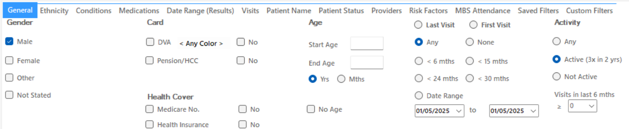

Now all filter criteria have been set, please click on **'Recalculate'** to apply the filter:



To see the full report, first minimise the filter panel by clicking on the     in the top left corner.

**REPORT STEPS**

Select the **‘MBS Eligibility’** tab. The **‘Health Assessment Eligibility’** subtab will appear by default. This report automatically filters for the eligible patient population.

Select the **‘HC 45-49 Never Claimed’** graph.

"CAT4 only tracks MBS items billed at your practice. Some patients may have claims elsewhere, but as we've filtered for active regular patients, these assessments should ideally be done in your clinic."

**Note:** If your selected patient group is too large, refine your reporting criteria to keep numbers manageable for clinic staff. Practices may adjust filters and reporting methods at their discretion.

For assistance in narrowing reporting numbers, contact the PHN at practicesupport@ddwmphn.com.au.

On the right-hand side of the Reports pane, you will see **‘Export’** and **‘Print’** icons.

You can save a soft-copy by selecting **‘Export’** or a hard-copy by selecting **‘Print’**.

If you chose to export a soft copy of your report, click on the drop-down arrow next to the Floppy Disc **‘Save’** Icon. This is where you will select how you would like to save the file.

**PDF:** Fixed Layout Document

**DOCX:** Word Document

**XLSX:** Excel Spreadsheet

**CSV:** Excel Data Table - great for bulk recall-reminders using HotDoc etc.

**Note:** If you intend to send a bulk recall using HotDoc please save as a CSV file and refer to the **‘CQI Toolkit: Recalls – CAT4 via HotDoc Broadcast’** document provided on the PHNs QI webpage.

Be sure to attach your data reports to your PDSAs at the beginning and end of each quarter. If it’s not recorded, it didn’t happen! Should the Department come searching, you **MUST** have a record of your QI activities and the treasure trove of data to prove it. **X marks the spot—bury it somewhere you'll always find it!**

**Unlock powerful data insights at the click of a button with PHN Exchange**

You may find the **PHN Exchange GP Hub Data Reports** useful as a complementary reporting resource. The PHN Exchange is an innovative, web-based quality improvement tool that allows your practice to benchmark its data against the PHN catchment average. This provides valuable insights to identify areas for improvement. Practices that share data with us can access PHN Exchange through the PHN Exchange Portal. Benchmarking reports can help track progress, align with PIP QI activities, and support strategic planning for proactive practice management.

To access the PHN Exchange please visit [DDWM PHN Exchange Portal](https://phnexchange.com.au/home.html?phn=304)

Your practice can monitor trends over a **12-month period** through the **GP Hub**.

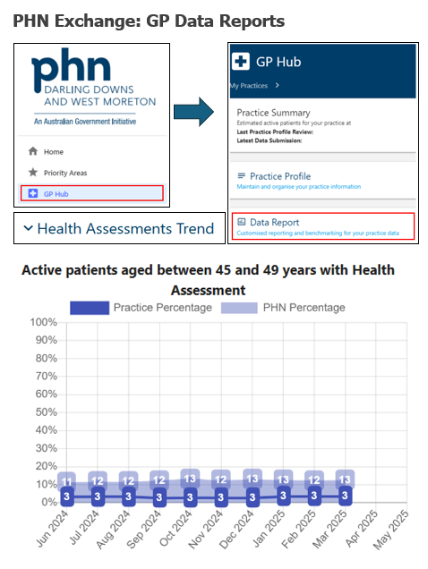

If you require assistance accessing or navigating your PHN Exchange data reports, please contact your PHNs Primary Care Liaison Officer or email [practicesupport@ddwmphn.com.au](mailto:practicesupport@ddwmphn.com.au)





You've conquered this QI Quest and **LEVELLED UP** your practice— but the journey doesn’t end here. A new challenge awaits in the next quarter... **Are you ready to embark on your next QI adventure?"**