KEY ACTIONS
for accrediting agencies
and general practices

Accreditation assessments
in 2022

Background
Under the National Health Reform Act 2011, the Australian Commission on Safety and Quality in Health Care (the Commission) is responsible for coordinating the National General Practice Accreditation (NGPA) Scheme, which provides for accreditation of general practices to the Royal Australian College of General Practitioners (RACGP) Standards for general practices.
This fact sheet describes how scheduled accreditation assessments may proceed in 2022 for general practices impacted by COVID-19.

Impact of COVID-19
The COVID-19 pandemic continues to create challenges for the health system. In some instances, this may impact the ability of general practices to participate in on-site accreditation assessments.
It is anticipated that the ongoing uncertainty related to the COVID-19 pandemic may impact the health system throughout 2022 due to:
- Diverted resourcing to support COVID-19 related activities
- A high proportion of furloughed members of the workforce
- Travel restrictions as a result of public health orders
- Ban of non-essential visitors at facilities, in line with public health orders.
These factors will in turn impact the ability of general practices and accrediting agencies to participate in accreditation assessments.

Accreditation assessments in 2022
To provide certainty for general practices, and facilitate accreditation assessments proceeding where possible, the following provisions for accreditation assessments will apply during 2022:
- On-site assessment is to proceed, whenever safe and feasible.
- Hybrid assessment may occur where it is not possible for a full assessment team to be on site. This assessment involves part of the assessment team being on site and part of assessment team off-site. The off-site team will participate in the assessment using videoconferencing technology to observe, interview and assess.
- Off-site virtual assessment may be allowed in exceptional circumstances. Virtual assessments involve all members of the assessment team using videoconferencing technology off-site to observe, interview and assess. All virtual assessments must be followed up with an on-site assessment.
- Accreditation can be maintained and the accreditation expiry date revised by up to six months. This option is available to general practices with assessments scheduled before 31 July 2022 that are experiencing COVID-19 related disruptions or unable to proceed due to public health orders imposing travel and border restrictions. This is assessed on a case-by-case basis. For eligible general practices the minimum time required to complete assessments will be granted.
Table 1 provides a detailed breakdown of the 2022 accreditation assessment model.

How to proceed with a hybrid or virtual assessment, or maintenance of accreditation?
Accrediting agencies are to use the decision support tool at Attachment 1 when determining whether changes for accreditation assessments are required for a particular general practice.
General practices who meet the criteria and believe they are eligible to apply for changes to accreditation assessments should discuss this with their accrediting agency.
Accrediting agencies will need to submit an application, including supporting evidence, to the Commission on behalf of the general practice.
Based on the evidence and rationale provided, the Commission will determine approval on a case-by-case basis.
Accrediting agencies and general practices must comply with requirements set out in Attachment 2 when proceeding with a hybrid or virtual assessment.

Questions?
For more information, please visit the NGPA Scheme webpage on the Commission’s website.
You can also email the Safety and Quality Advice Centre at AdviceCentre@safetyandquality.gov.au or call 1800 304 056.

Table 1: 2022 accreditation assessment model
Assessment mode |  | Indicators to be assessed | Assessment due | Remediation period | Accreditation award
On-site assessment |  | All RACGP indicators | More than four months before accreditation expires | 65 business days, between initial and final assessments | Three years
Hybrid assessment |  | All RACGP indicators | More than four months before accreditation expires | 65 business days, between initial and final assessments | Three years
(i) Virtual assessment | Off-site assessment | All RACGP indicators | More than four months before accreditation expires | 65 business days, between initial and final assessment which includes the four‑week period between assessments | Three years
Followed by: | On-site assessment | - Indicators rated as not met at the virtual assessment  - Observation of clinical areas  - Review of high-risk scenarios | Within four weeks of virtual assessment
(ii) Virtual assessment | Off-site assessment | All RACGP indicators | More than four months before accreditation expires | 65 business days, between initial and final virtual assessments | 18 months
Followed by: | On-site assessment | - RACGP specified indicators  - Indicators rated as not met at the virtual assessment  - Observation of clinical areas  - Review of high-risk scenarios | Less than 12 months from conclusion of virtual assessment | 65 business days, between initial and final assessments | 18 months
Or: | On-site assessment | All RACGP indicators | Less than 12 months from conclusion of virtual assessment | 65 business days, between initial and final assessments | Three years

Attachment 1: Decision support tool for accrediting agencies
This tool is developed to help accrediting agencies determine how to proceed with accreditation assessments when the accrediting agency or general practice is impacted by COVID-19.
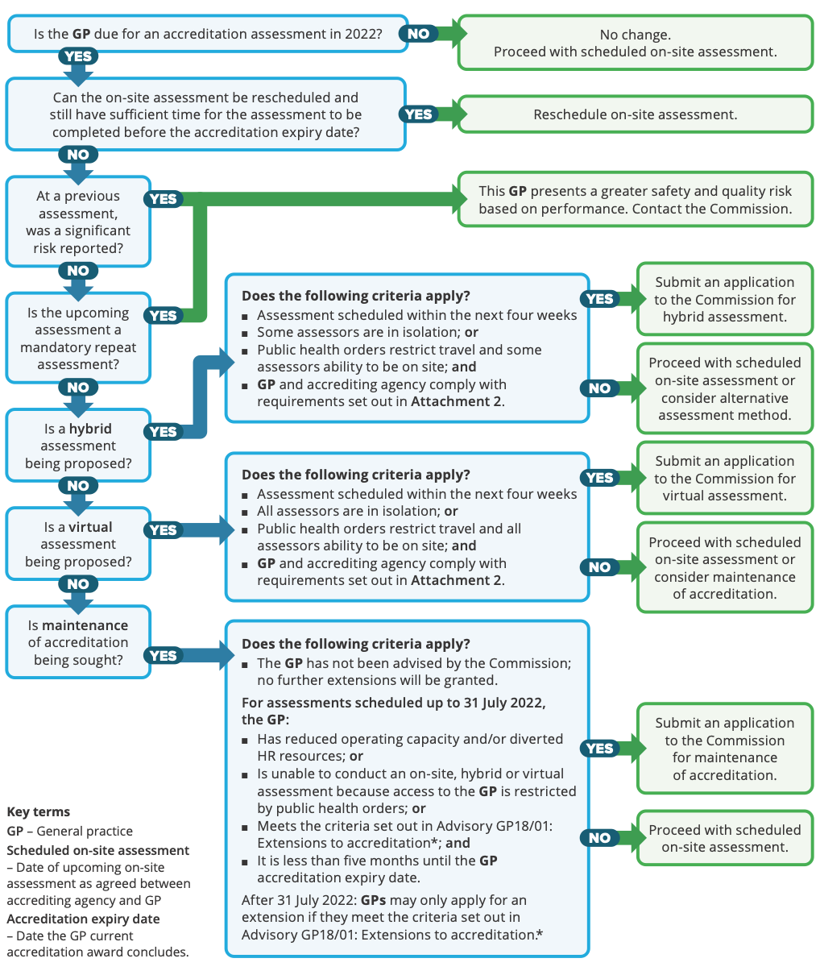
* Advisory GP18/01: Extensions to accreditation.

Attachment 2: Guidance on conducting
hybrid or virtual assessments

Requirements for hybrid or virtual assessments
- Accrediting agencies must seek approval from the Commission prior to conducting a hybrid or virtual assessment
- Must comply with local, state and territory confidentiality and privacy laws
- Accrediting agencies and assessors must comply with the requirements of the NGPA Scheme (such as rating scale, initial assessment and threshold for mandatory re-assessment) and ensure the assessment processes are rigorous
- For hybrid assessments, a member of the assessment team must be on site throughout the assessment
- Assessors must take all necessary steps to ensure that the integrity of the assessment is not compromised and that the number, scope and type of examination and interviews are consistent with an on-site assessment
- All relevant areas within the general practice must be viewed and assessed
- The length of an accreditation assessment must be extended if needed, for example, limited numbers of assessors are on site
- The general practice assessment report must specify that a hybrid or virtual assessment was performed, the locations that were assessed virtually and note any limitations to the assessment or technical difficulties encountered.

Approval to conduct a hybrid or virtual assessment

Administration

Accrediting agency
Conduct a risk assessment and feasibility review to ensure a robust hybrid or virtual assessment can be conducted, including consideration of:
- Information communication technology (ICT) availability, capacity, security and reliability
- Size and complexity of the general practice
- Maturity of the general practice’s safety and quality systems
- Information on the general practice’s layout
- The extent and location(s) where virtual assessment will be used.
If a hybrid or virtual assessment is feasible and meets the criteria, seek approval to conduct the assessment from the Commission. The application must include a rationale for undertaking a hybrid or virtual assessment.

General practice
Participate in or provide information for the risk assessment and feasibility review.

Prior to a hybrid or virtual assessment

Administration

Accrediting agency
Where approval has been granted:
Agree on the format of reviews to be conducted in operational areas, including:
- The involvement of and capturing consumers in the camera view
- The need for a virtual tour of the general practice at or prior to the commencement of the assessment
- Asking for a map of the general practice so assessors can orientate themselves during the assessment
- Considering time zones for assessors and general practices when agreeing the schedule of events
- Agreeing on mechanisms of communication with general practices during the assessment
- Agreeing on mechanisms of communication between assessors during the assessment.
Ensure all of the assessment team members:
- Know and understand their role and responsibilities during the assessment, and ensure the tasks are well defined
- Have the skills and/or the support to use the ICT equipment
- Understand the risks and limitations of hybrid or virtual assessments, particularly in relation to evidence gathering and the robustness of the assessment.
Ensure sufficient time is allocated to testing of ICT equipment prior to the hybrid or virtual assessment, using the same equipment that will be used during the assessment, and in areas where the assessment will be conducted.
Identify the mechanism by which assessors will keep in contact during the assessment, individually and through group chat. Ensure this mechanism is secure at all times and that the record of the conversations can be fully deleted at the end of the assessment.
Develop a contingency plan, that includes actions and responsibilities for situations including when the:
- Video link is disconnected
- Voice link is unavailable
- WiFi is unavailable
- Assessment has to be discontinued
- General practice workforce is unable or does not comply with the reasonable requests during the assessment.
Clearly articulate to the general practice, in writing if necessary:
- The contingency plan and process should the assessment not be able to proceed
- The consequences of members of the general practice’s workforce not following an assessor’s reasonable direction, particularly in regard to the movement and placement of the camera, volume of the microphone, sharing of documents.

General practice
- Provide assessors with a time limited clearance to the relevant programs and areas in the general practice’s ICT systems
- Provide assessors with a security briefing or instructions, if required
- Ensure ICT devices are fully operational and charged
- Nominate an ICT support person to be responsible for the integrity and operation of the ICT systems during the assessment
- Ensure the nominated ICT support person is available to the assessors throughout the assessment
- Provide contact details to assessors for all key contacts in the general practice
- Agree to a contingency plan with the accrediting agency in the event the assessment cannot be finalised as scheduled.

Information and communications technology systems

Accrediting agency
If the ICT program is specified by the general practice, prior to the assessment test the ICT programs and equipment to be used to ensure the IT equipment has the functionality and flexibility required for a robust assessment.
If the ICT equipment is not specified by the general practice, determine which platform will be used by assessors after considering:
- Capacity of the program to share screens for the review of documents
- Ability of the assessor to take control of the screen
- Availability of breakout rooms for assessors to undertake review independently
- Capacity to view documents in real time, including clinical and personnel files, using high resolution camera/photography
- Mobility of ICT equipment, including stability of the network.

General practice
Confirm with the accrediting agency the videoconferencing software and ICT platform to be used during the assessment.
Ensure there is sufficient appropriate ICT equipment available for the assessment to proceed. If the assessment includes multiple sites, ensure there is sufficient supports and equipment at each site for the assessment to proceed.
Ensure documents to be presented as evidence can be made available securely to assessors, using for example drop box or other secure sites.
Test the IT equipment with those involved in the assessment:
- Ensure all of the workforce involved in the assessment have the IT skills and/or support to operate the IT equipment, including camera focus, volume and screen sharing
- Simulate a virtual tour of the general practice to test visibility, voice quality and the appropriate speed of camera movements in order for participants to be able to view objects and text clearly.
Check all locations where the assessment will be conducted to identify areas where the WiFi signal may be weak or not accessible. Address any issues identified with the WiFi coverage.

Documentation

Accrediting agency
Develop a policy for recording and photographing during the assessment sessions conducted using virtual access digital technology and provide a copy to the general practice.

During a hybrid or virtual assessment

Administration

Accrediting agency
Limit the length of each session to ensure the virtual assessments are manageable for assessors.
At the commencement of each interview or assessment session, clarify for participants:
- If the meeting is being recorded
- How and what documents will be accessed for review during the session
- How security of data will be maintained
- That the assessors through verbal direction and cues will have control of the camera direction, placement and movement at all times.
Assessors should:
- Ensure their camera is positioned so the assessor’s full head and shoulders are visible to those in the general practice
- Be located in a private, quiet environment to avoid interference, background distractions and noise
- Be mindful of the background view of their location, and ensure it is appropriate
- Use headphones or other equipment to maximise the capacity to hear and focus their attention, e.g. headsets with a microphone or noise cancelling headphones
- Remain in control of the camera viewing the general practice at all times
- Issue clear and direct instructions to members of the general practice’s workforce if they are physically responsible for moving and positioning the camera
- Use check-back techniques to ensure what has been said is clearly heard and understood, particularly where there are poor or unstable IT connections
- Terminate the interview, observation, or the assessment if there is continued poor connections or inability to retain a connection, or where the general practice fails to comply with reasonable directions from the assessor
- Implement the contingency plan if the assessment is terminated.
Where virtual breakout rooms are used, ensure privacy is maintained by inviting participants, nominating rooms and virtually locking the room once a meeting has commenced.
Where meetings are recorded, assessors are to seek agreement from all participants before the meeting commences and provide a clear statement on how the recording will be used and if/when it will be deleted.
Ensure that communication between assessors occurs regularly to share findings.
For hybrid assessments, direct assessors that are on site to follow up issues that have been identified by assessors using virtual access digital technology.

General practice
If consumers are involved in the assessment, obtain permission and provide them with information on the hybrid or virtual assessment processes.
Recognise that a general wide sweep of the camera does not need permission and is similar to an assessor being on site.

Information technology systems

General practice
Ensure the ICT equipment being used during the assessments:
- Can be moved on a stable surface, such as a trolley to all locations where the assessment is to occur
- When being moved through a facility, the camera is facing forward
- Complies with infection prevention and control requirements for equipment being moved between clinical areas
- Is fully charged and includes backup power supply, if required.
Do not use virtual backgrounds during assessments. These reduce the likelihood of opportunistic observation of practice and environment.

Documentation

Accrediting agency
Document in the final assessment report to the general practice:
- The reason a hybrid or virtual assessment was conducted
- The sections of the assessment conducted using virtual access digital technology
- Actions that could not be evidenced or not fully evidenced by virtual assessment
- Barriers, technical difficulties and/or enablers during the assessment.
Where an assessment is prematurely terminated and does not recommence document:
- The actions still to be assessed
- The plan and timelines for the assessment to be finalised
- Reasons for changes to assessment schedule
- Areas not yet reviewed or not fully reviewed by the assessment process
- Other options, including ICT systems considered or used to complete the assessment
- The proposed action for the completion of the assessment, including
  - date for the completion of the assessment
  - format for the completion of the assessment
  - additional costs, if any
  - implication and/or consequences of the delay.

General practice
At assessment:
- Ensure all relevant documents are readily available or easily accessible to avoid delays waiting for documents to display
- Ensure ICT system has the functionality to enlarge documents if necessary so they can be read by assessors.

After a hybrid or virtual assessment

Administration

Accrediting agency
Remove and delete any documents, images, or recordings accessed through the ICT system at the conclusion of the assessment.
Use the agency’s monitoring systems to evaluate the effectiveness of the sessions of the assessment conducted using virtual access digital technology and ways to improve its effectiveness, including but not limited to:
- Understanding and use of technology
- Training of assessors
- Information and instructions provided to general practices
- Design of the assessment schedule
- Mix of on-site assessors and those present via virtual access digital technology
- Role of assessors present via virtual access digital technology compared with role of assessors on site
- Planning processes
- Contingency planning.

General practice
- Revoke assessors ICT and security access
- Evaluate the effectiveness of the hybrid or virtual assessment and provide feedback to the accrediting agency and the Commission.

Documentation

Accrediting agency
Assessment reports and testimonials are to state the assessment was a hybrid or virtual assessment.

safetyandquality.gov.au
© Australian Commission on
Safety and Quality in Health Care 2022

